

Presenter Pack

The following document is a guide for Producers to prepare a Presenter Pack of their touring show.

This is a guide only. You can change the style, format and design of the document. Or if you already have a Presenter Pack, you may wish to refer to the following guide to check if you are missing any information.

Instructions for use
- Be honest about the work, the requirements of the show and what you expect from venues.
- Fill in as much information as possible (but do not make up information).
- Delete any headings not applicable to the touring show.
- Any text shown in square brackets [ ] requires the producer to update. Eg [Show name] in the footer.
- Red italic text is example / instructions.
- Note any areas in which you are flexible (eg, the type of audience engagement, or the type of venue) and areas in which you are not flexible (eg, PA must be supplied by venue, one technician is required to operate the show etc).

Checklist
- Have you added an image to the front page?
- Have you updated the [Show name] in the footer?
- Have you consulted other personnel in the company to seek their input (eg marketing and technical)?
- Have you updated the table of contents?
- Have you deleted the instructions page (this page)?
- Have you saved the document as a PDF (this will ensure your formatting remains intact)
- Have you uploaded it to your arTour production profile page?

Deep Culture, Fresh Vibrations
By Multicultural Arts Victoria

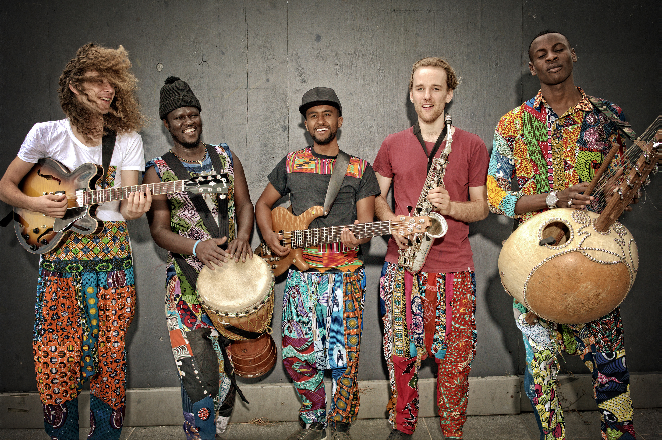
Credit: Michelle Grace Hunder

PRESENTER’S INFORMATION


Contents

COMPANY PROFILE 4
ABOUT THE SHOW 4
PERFORMANCE SPECIFICS 4
AUDIENCE ENGAGEMENT 5
MARKETING 5
PRODUCTION DETAILS 6
CONTACTS 8

COMPANY PROFILE
Multicultural Arts Victoria (MAV) has evolved over four decades into one of Australia’s most important bodies for the discovery, development and promotion of culturally and linguistically diverse (CALD) contemporary art, heritage and cultural expression. Over 1 million participants are engaged in our program which includes long-term initiatives for career development and creative capacity building for over 2,000 artists and 500 communities from diverse and emerging backgrounds. The organisation also offers expertise in audience development, community engagement and artistic excellence with CALD communities. We would like to take this show on tour to expose communities to the incredible talent that is present in Australia from diverse communities. We would love to showcase cross-cultural collaborations across the nation and hopefully spark new ones in the communities we touch.

ABOUT THE SHOW

SHOW SYNPOSIS
Contemporary Jazz was birthed from the Atlantic slave trade that brought nearly 400,000 Africans to North America. Traditional rhythms and melodies combined with European American musical parentage to create what we now know as Jazz. However, due to a different form of migration to a very different environment, Australia is now witnessing the emergence of a unique sound that encompasses the original rhythmic African descendants of Jazz with contemporary styles, but in an Australian setting. The Senegambian Jazz Band demonstrates this new sound.

The Senegambian Jazz Band (TSJB) incorporates traditional rhythms and scales from across Africa with contemporary jazz syncopation and improvisation. TSJB heralds world renowned and internationally touring musicians, legends in their homelands and descendants of a long line of musical griots, alongside highly trained Australian-born Jazz musicians. The band’s front man, Amadou Suso is an internationally touring Kora virtuoso. He is a direct line descendant of the first ever Kora player who lived 760 years ago, with the original Kora remaining in the family and has been referred to as the Jimi Hendrix of the Kora.

The production will feature one or two sets (optional), followed by interactive workshops, highlighting the nation’s role in championing a new international sound.

ACKNOWLEDGEMENTS
6 x Artists
1 x Production/tour/tech manager
Multicultural Arts Victoria logo to be included on event collateral

BIOGRAPHIES
Featuring an internationally renowned lineup that traverses The Gambia, Senegal, Ethiopia, Ghana and Australia, the Senegambian Jazz Band channels over eight thousand years of African musical traditions, transporting the power and beauty of these ancient sounds, rhythms and melodies to euphoric audiences across Australia.
Fronting the seven-piece band is the phenomenally talented Amadou Suso, direct descendent of the world’s first kora player, Koriang Musa Suso. As a music maker, or ‘jali’ by birthright, Amadou embodies the griot traditions of the Mandinka of West Africa. Known widely as the 'Jimi Hendrix of the kora', Amadou fulfils his ancestral duties to share the culture of his people through an intoxicating contemporary mastery of the African harp.
Complementing the band's sublime kora-led melodies are the formidable percussive talents of Boubacar Gaye, from Senegal, on the djembe and congas, and Julius Sackey, from Ghana, on drum kit. World-class musicians in their own right, Boubacar and Sackey harness the rhythms of West Africa, providing the irresistible foot-stomping drum beats that see fans losing themselves in the music and dancing the night away.
Linking in on bass is mainstay of the international Ethio-music scene, Yoseph Bekele. With his skillful grasp of the group's polyrhythmic elements, Yoseph seamlessly connects the band's harmony and groove, adding his own unique Ethio-jazz flavour. Add to the mix the soulful strains of Tom Benson on sax and the slicing electric guitar solos of Luke Koszanski, and the Senegambian Jazz Band is ready to enchant global audiences with an elaborate and joyful sound that is paving the way for a new African jazz genre.

PERFORMANCE SPECIFICS

DURATION
Act 1 – 45mins – 1 Hour
Interval – 15 minutes
Act 2 (interactive Workshop/masterclass – 30 minutes

SUITABLE VENUES
Outdoor, indoor, festivals, arts centres, parks, bars, music venues, theatres. Very flexible.

MAXIMUM NUMBER OF PERFORMANCES PER WEEK
5 x performances

MINIMUM BREAK BETWEEN PERFORMANCES
60 minutes

LICENCING AGREEMENTS
N/A

APRA OBLIGATIONS
N/A

TOURING PERSONNEL
The touring party consists of 7 people.
List the touring personnel below.
Name | Role
Billy Zeik Kelleher | Tour/Production Manager
Amadou Suso | Musician
Luke Koszanski | Musician
Boubecar Gaye | Musician
Yoseph Bekele | Musician
Tom Benson | Musician
Julius Sackey | Musician

PERFORMANCE HISTORY
The band has played hundereds of gigs around Melbourne and Victoria, They have had an ongoing 6 month residency at Bar Ousseau – One of Melbourne’s leading music venues. They have played in Federation Square, Fairfield Amphitheatre, MONA FOMA, Melbourne Town Hall, Queen Victoria Night Markets, Castlemaine Festival and many more. The band has also played in Japan.

AUDIENCE ENGAGEMENT

OVERVIEW
On the most basic level the community would benefit from seeing this show by seeing the potential in cross-cultural collaboration and in being exposed to the exciting new sonic landscape being traversed in our country. Workshops and master classes would be valuable to musicians and students through the introduction of new instruments and musical styles. Conversations around the musician's journeys have the potential to inspire members of CALD communities. The production also holds the potential to spark new and exciting collaborations within the Queensland communities where the performance takes place.

DESCRIPTION / DETAILS
- New rhythms/Musical Styles
- Cross-cultural music making
- Ancient Instrument crafting
- Collaborative performance
- Audience is not required to bring equipment though for a performance masterclass (interest dependent) audience would need to bring instruments

COST
One off fee for presenter + Royalties

TARGET AUDIENCE FOR COMMUNITY ENGAGEMENT
The show is for all ages. Workshop/masterclass would be bets for 16-55 years old.

MARKETING

MARKETING COPY
One line

An explosive performance tracing the journey of Jazz back to its ancestral roots with master musicians from Ethio-Jazz and the Kora infused pan-African troupe Senegambian Jazz Band.

Short
The Senegambian Jazz Band (TSJB) incorporates traditional rhythms and scales from across Africa with contemporary jazz syncopation and improvisation. TSJB heralds world renowned and internationally touring musicians, legends in their homelands and descendants of a long line of musical griots, alongside highly trained Australian-born Jazz musicians. The band’s front man, Amadou Suso is an internationally touring Kora virtuoso. He is a direct line descendant of the first ever Kora player who lived 760 years ago, with the original Kora remaining in the family and has been referred to as the Jimi Hendrix of the Kora.

Extended
Made Available on request

MARKETING SUMMARY
Provide a summary of marketing available, including target audiences, marketing notes, what marketing has been successful in the past etc.

MEDIA QUOTES
Provide media quotes if applicable.

AUDIENCE REVIEWS
“Amadou Suso is the Jimi Hendrix of the Kora!”
Online review of Senegambian Jazz Band

COLLEAGUE RECOMMENDATIONS
“Get them on stage now while you still can” – Andy Miller, GM- Multicultural Arts Victoria

VIDEO LINKS
https://youtu.be/QrUh3LR07VE

MAGES
Available on request

MARKETING MATERIALS
Available on request

CONTENT WARNINGS / AUDIENCES TO AVOID
No

SPONSOR OR OTHER ACKNOWLEDGEMENTS
Multicultural Arts Victoria -

TEACHER’S RESOURCES
N/A

PRODUCTION DETAILS

TECHNICAL SUMMARY
1 x vocal mic, 4 x percussion mic, 1 x drum kit + mic set up, 1 x DI, 1, bass amp, 1 x guitar amp, 6 x foldback

EXAMPLE SCHEDULE
6:00pm Bump in
6:45pm Sound Check
7:30pm Performance

CREW REQUIRED FROM VENUE
1 x sound tech though not necessary requirement

STAGE
Production is flexible

[Company] to supply
Artists, instruments

Venue to supply
, basic lighting (not necessary), water, back line if possible

LIGHTING
Anything available

[Company] to supply
n/a
Venue to supply
Anything available

SOUND
6 piece band, basic set up

[Company] to supply
instruments

Venue to supply
PA, foldback – backline (incl. drum kit) if possible

FREIGHT NOTES
We will hire a van

CONTACTS
Billy Zeik Kelleher – Artist Services – Multicultural Arts Victoria
Ph. 03 99188 3681
Mob. 0416 093 214
Email. Billy.kelleher@multiculturalarts.com.au

